1
Go together in pairs. Stand close to your partner so that the referee can bind your inner legs together. See the picture!
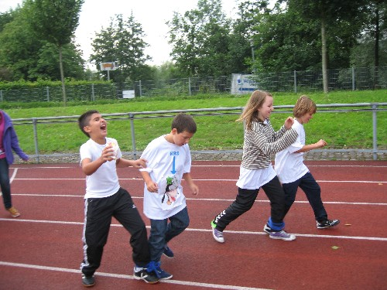
Run along the track as fast as you can. The referee measures the time.

Material Station 1/ Dreibeinlauf
- min. 2 Seile
- Stopuhr/ Handy
- gekennzeichnete Strecke
- Hütchen / Klebeband

2
Take a run-up and jump off the
leather top with one foot.
Jump as far as possible.
The referee measures the length.
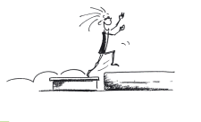

Material Station 2 Weitsprung
- Kastenoberteil
- Weichsprungmatte
- Klebeband für Weitenmarkierung.
- 3 Weiten mit je 1,2 oder 3 pts auf Matte markieren

3
Make up an acrobatic act.
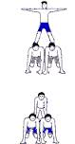
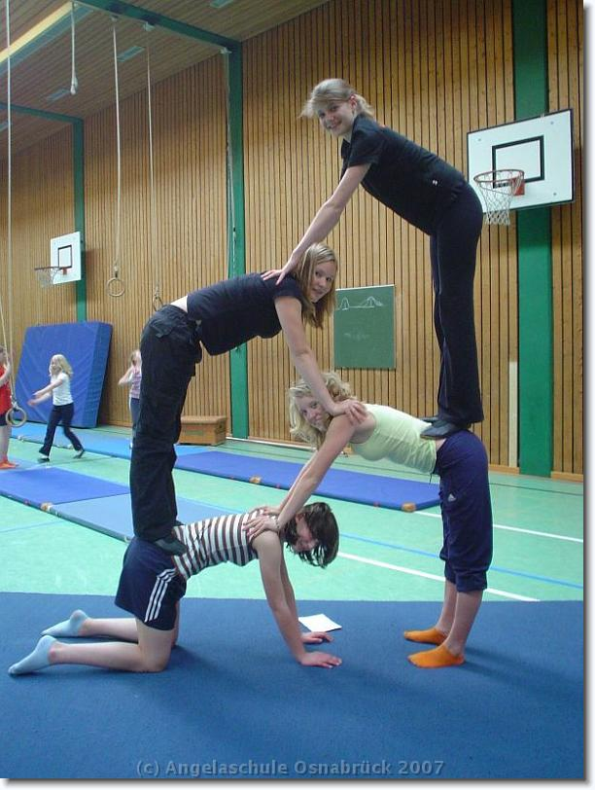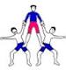

Material Station 3 Akrobatik
- Bodenläufer oder 4 Turnmatten (blau, geklettet)
- bei gelungener Pyramide gibt es 5 Punkte, 3 Punkte oder 1 Punkt je nach Qualität

4
Carry the basketballs between your legs from one side into the box on the other side without falling off the rope.
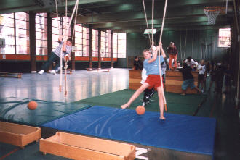

Material Station 4 Balltransport
- Taue
- Matten
- 4 Basketbälle
- 2 Kastenteile
- Punkte: pro Ball einen Punkt

5
Go together in pairs. One of you is the horse, the other one is the rider. Gallop the track as fast as you can.
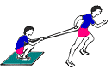
The referee measures the time.

Material: Station 6Pferderennen
- 4 Hütchen oder Stangen zum Parkour abstecken
- 2 Teppichfließen
- 4 Seile
- Stopuhr /Handy

6
Two teams against each other.
All of your team have to jump on the soft floor mat at the same time. Try to move the mat as fast as possible to the other side of the gym only by jumping on it.
Only the winning team gets points.

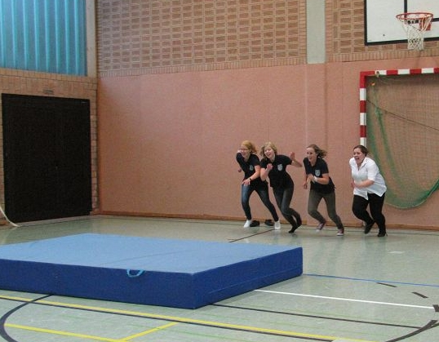
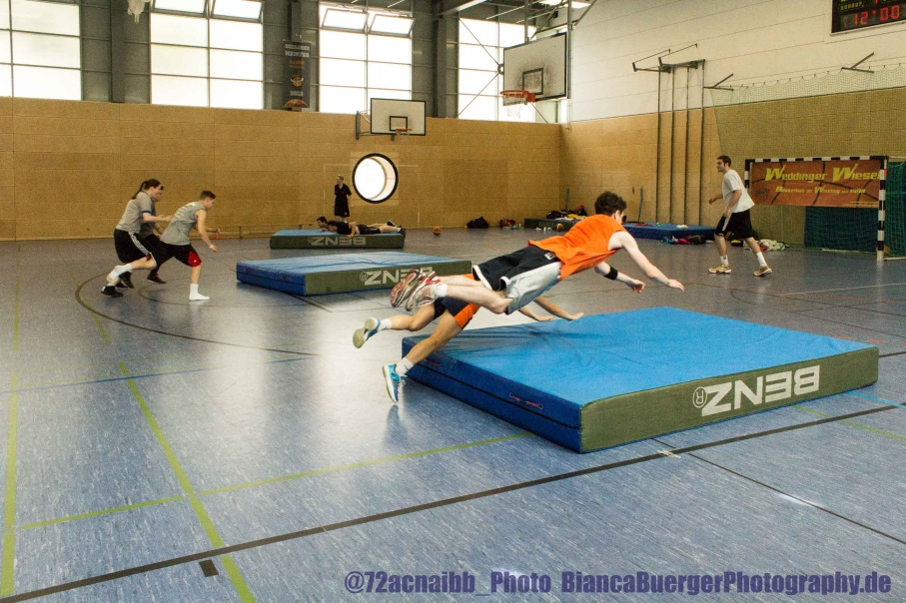
Material Station 6 Mattenrutschen
- 2 Weichbodenmatten
- viel Platz

